W-11
YEAR 12 PHYSICS
ASS. 6 - WAVES + ATOMIC PHYSICS

NAME: TOTAL: 

1. In April 2009, New Scientist magazine reported the discovery of several species of fish that emit red
light as a means of communication. This was surprising because these fish swim at depths where
wavelengths corresponding to red light do not penetrate but blue light does . The fish might produce
red light using a fluorescent protein that absorbs blue light and then emits red.

(a) Draw an energy level diagram showing possible electron transitions taking place in the atoms of
the fluorescent protein that could give rise to the observed phenomenon.

(3)

(b) Calculate the energy in joules of a photon of blue light and a photon of red light. Blue light has
wavelength of 4.00 x 10² nm and red light 7.00 x 10² nm. Use the energy values to label the
transitions in the diagram you drew in part (a ).

(3)
2. The graph below shows the trace of a sound displayed on a cathode ray oscilloscope (CRO). The
horizontal (x) axis is time and the vertical (y) axis is amplitude.

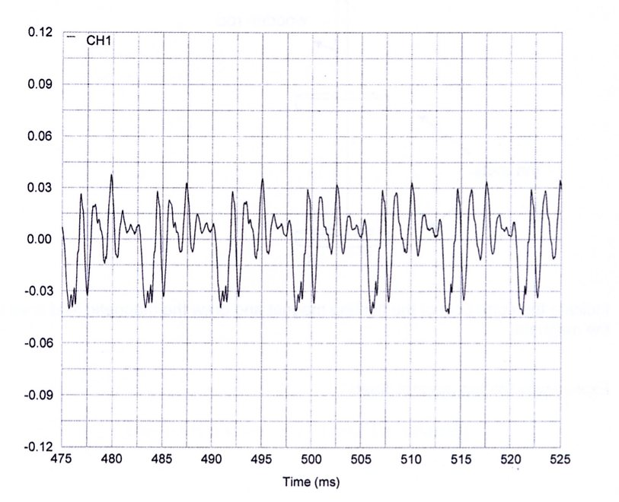

(a) Is the above trace noise or a musical note? Explain your reasoning.

(2)

(b) Describe the effect on the trace if the sound wave was louder.

(i) Effect on the shape of the trace.

(ii) Effect on the amplitude of the trace

(2)

3. Two identical tuning forks vibrate at a frequency of 256 Hz. One of them has a drop of wax placed on
it. This lowers its frequency. When the two tuning forks are sounded, 6.0 beats per second are heard.
What is the frequency of the tuning fork with the wax on it? Show your working.

(3)
4. The energy level diagram for a hypothetical atom is shown below. On this diagram draw arrows to
show the transitions that would produce emission and absorption spectra for this atom. Indicate which
transitions are responsible for the absorption spectrum and which for the emission spectrum.

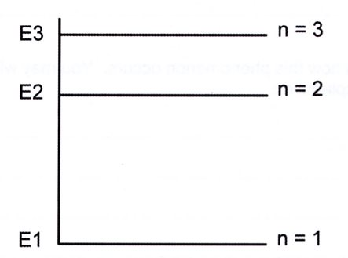

(3)

5. A 1.00 mW light source emits a narrow beam that shines on a screen. The wavelength of the light is
633 nm.

(a) Calculate how many photons strike the screen per second.

(3)

(b) If the power of the beam is doubled, which of the following statements is true? Circle your
answer.

A. The photons travel faster.
B. Each photon has more energy.
C. More photons hit the screen every second.
D. The frequency of the light is doubled. (1)

6. For the three properties of a sound wave; frequency, wavelength and speed complete the table below
stating whether the property is changed or unchanged when undergoing reflection, refraction and
diffraction. One property for diffraction has been completed for you.

Property | Reflection | Refraction | Diffraction
frequency |  |  | unchanged
wavelength
speed
(4)
7. The following oscilloscope trace shows the superposition of two waves. The horizontal axis is in
milliseconds.
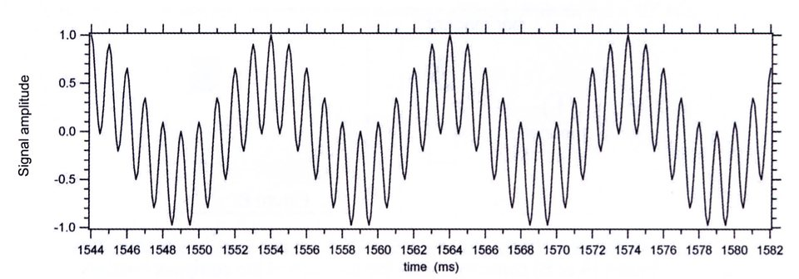
Calculate the frequency of each wave.

(4)

8. Some materials emit visible light when illuminated by ultraviolet light.

(a) What is this phenomenon called? (1)

(b) Explain how this phenomenon occurs. You may wish to draw a diagram to aid your
explanation.

(3)

9. There are three lines in the emission spectrum of hydrogen that occur in the visible part of the
electromagnetic spectrum. These involve transitions to the n = 2 energy level. The three lines have
the wavelengths 6.60 x 10⁻⁷ m, 4.90 x 10⁻⁷ m and 4.40 x 10⁻⁷ m.

(a) Draw an energy level diagram to illustrate the transitions from the n = 3, 4, 5 levels to the n = 2
level. Label the levels n = 2, 3, 4, 5.

(4)

(b) Which value of wavelength from the list above corresponds to the transition with the largest
energy difference? Explain your answer.

(2)

(c) The n = 2 level has an energy of -3.4 eV. The photon with wavelength 4.90 x 10⁻⁷ m
corresponds to the transition between the n = 4 and n = 2 energy levels . Calculate the energy of
the n = 4 energy level in eV.

(3)
The following passage describes how the redshift of a star or galaxy can be measured. To determine
the redshift, the absorption or emission spectra of the astronomical object are looked for. These can be
compared with known spectra of various elements and compounds existing on Earth. If the same
pattern of lines is seen in a spectrum from a distant source but occurring at shifted wavelengths, it can
be identified as originating from the same element or compound. If the same spectral line is identified
in both spectra but at different wavelength then the redshift can be calculated. Redshift is expressed in
terms of a parameter z.
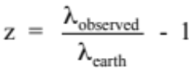

The redshift of the galaxy 8C is z = 4.25.

(d) Calculate the wavelength of the n = 4 to n = 2 transition in hydrogen that would be observed by
an astronomer studying the galaxy 8C.

(2)

10. (a) Apart from the phenomenon of vibrating air columns, provide one example in which resonance
may be observed. Explain how resonance occurs in the example that you have chosen.

(3)

A loudspeaker emitting a single frequency is held over a tube that has one end placed in a cylinder
of water at 25.0 °C. As the length of tube in the water is changed, the sound heard also changes. The
equipment is illustrated in the diagram below.
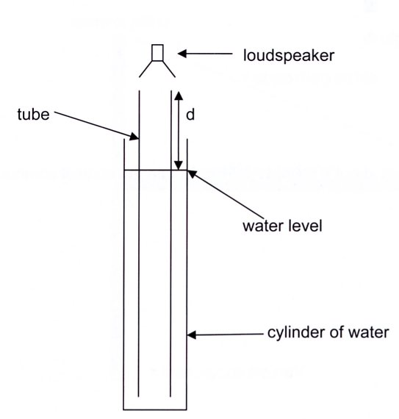

The first resonance is heard when the length of the air column above the water (labelled d in
the diagram) is 17.0 cm and a second is heard when the length of the air column is 49.0 cm.

(b) Calculate the wavelength of sound in the cylinder.

(2)

(c) Calculate the frequency being emitted by the loudspeaker.

(2)

(d) The diagrams below show very simple versions of a flute and a clarinet.
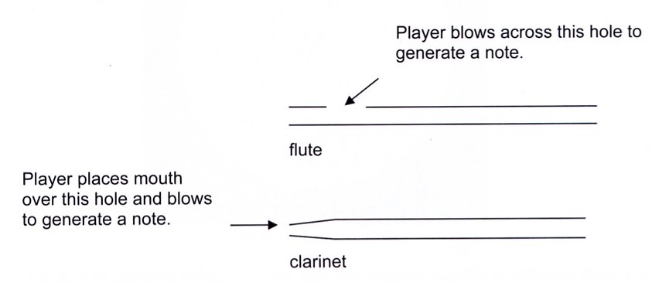

(i) The ratio of the first three frequencies heard in the flute f_{l}:f₂:f₃ is 1:2:3. Determine the
ratio of the first three frequencies heard in the clarinet.

(1)

(ii) Using your knowledge of vibrations in air columns, explain the differences between the
frequencies heard in the flute and those in the clarinet.

(3)

11. The diagram below shows the basic components of a stationary anode X-ray tube.
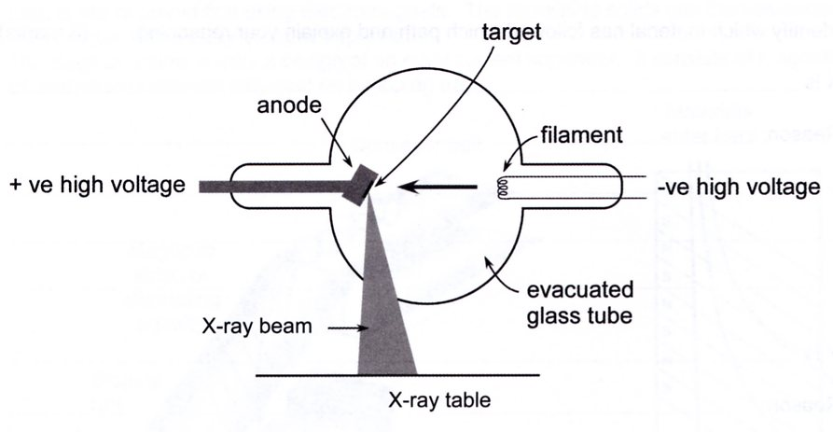

(a) Describe how X-rays are produced in the tube.

(4)

(b) An X-ray tube with a tungsten anode is operating at a peak voltage of 1.00 x 10² kilovolts.
Determine the upper limit in electron volts for the energy of an X-ray photon emitted from the
tungsten target.

(2)

(c) Exposure to X-rays is potentially more harmful than exposure to ultraviolet light.

(i) Explain why X-rays are so harmful compared with ultraviolet light.

(2)

(ii) Describe and justify two precautions that an X-ray operator must take to reduce their risk
of exposure.

One:

Two:

(4)

12. Two pipes open at both ends are 0.840 m and 0.850 m long. They are sounded together at their
fundamental frequencies and produce beats at the rate of 46 every 20.0 s.

(a) Calculate the beat frequency produced by the pipes.

(2)

(b) (i) Show that for two such pipes the beat frequency is equal to

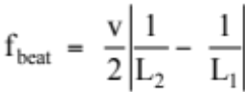

where: v = speed of sound
L₁= length of pipe 1
L₂ = length of pipe 2

(3)

(ii) Calculate the speed of sound for the situation described above.

(3)

(c) Calculate the fundamental frequency of the 0.840 m long pipe.

(2)

(d) If the gas in the 0.840 m pipe was replaced with carbon dioxide at 25.0 °C and 101.3 kPa,
would the fundamental frequency increase, decrease or remain the same? Explain your answer.

(3)

